**Instructions**

Create a new Power BI project called **Exercise – Profiling a dataset.** Follow the prompts below to complete the exercise.

**Step 1: Download the Excel files**

Download the *Other Company Products.xlsx* file, which you will use in this exercise. This file is available at the top of this exercise.

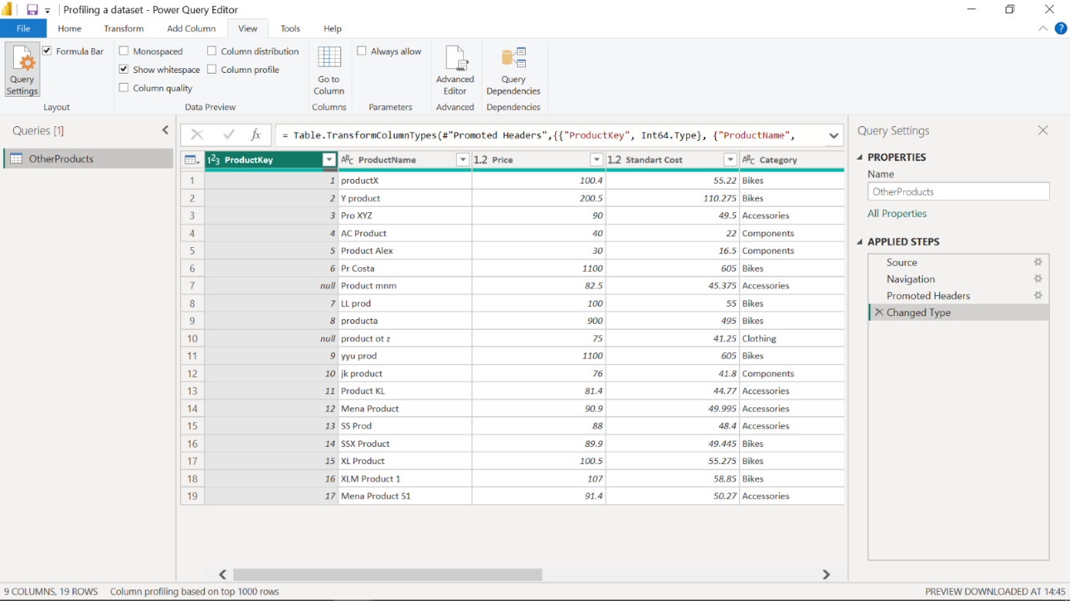

**Step 2: Open the Power Query Editor**

In Power BI, select **Get Data** and then select **Transform data** to open the Power Query editor and import your dataset, *Other Company Products*.

**Step 3: Detect empty values in ProductKey column:**

1. There are some empty values in the spreadsheet’s **ProductKey** column.
2. To detect empty and invalid values, you need to assess column quality, on the **View** ribbon tab, from inside the **Data Preview** group, check **Column Quality**. The column quality feature allows you to easily determine the percentage of valid, error, or empty values found in columns.

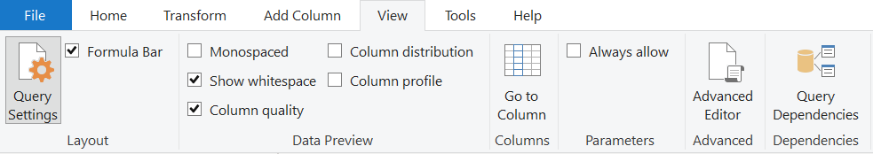

1. Note amount **Valid**, **Error** and **Empty** rows percentage values of the **ProductKey** column

**Step 4: Assess the distribution of product categories:**

1. There are many categories in **Product** list and you need to find out how the data is distributed by the category data.
2. To assess column distribution, on the **View** ribbon tab, from inside the **Data Preview** group, check **Column Distribution** and note the amount of **distinct** values and **unique** values. Check **Column Profile** while keeping **Column Distribution** checkbox as checked and note the number of Bikes, Accessories, Components and Clothing.

**Step 5: Detect potential anomalies in the Price column**

1. You have to assess **Price** column in the **Product** list and you need to find out **min**, **max**, **mean** values and the distribution of the values.
2. To detect potential anomalies and assess column distribution for the Price column, on the **View** ribbon tab, from inside the **Data Preview** group, check **Column Profile** while keeping **Column Distribution** checkbox as checked.
3. Note the min, max, mean values for the **Price** column and also note assess the column distribution.